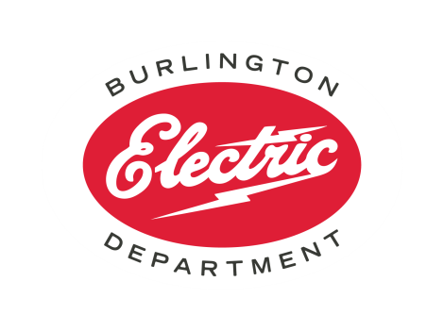
Scholarship Application
Please answer each question in 100 words or less. Applications are accepted on a rolling basis. Please email completed form to mailto:efficiency@burlingtonelectric.com.

- Why are you interested in attending this class?

- How would you utilize your newly acquired knowledge to advance construction practices in Burlington?

- Please tell us about a recent or planned renovation or new construction project that could be classified as high performance/low-carbon. What were the keys to the project’s success and what were the obstacles?

- If you have experience working in Burlington, how could BED and the City help to improve the outcome of your projects?

(BED will not share your contact information)
Name_______________________________________
Email________________________________________
Business Name________________________________
Mailing Address________________________________
Phone Number_________________________________

